

Technion

*Electrical Engineering Department*

High Speed Digital System Lab

Project Documentation

**Internal Logic Analyzer Core**

Students: Moran Katz, Zvika Pery

Mentor: Moshe Porian

TABLE OF CONTENT

1 INTRODUCTION 6

1.1 ABSTRACT 6

1.2 PROJECT GOAL 6

1.3 PROJECT REQUIERMENTS 6

1.4 TOP ARCHITECTURE 7

1.5 ENGINEERING TOOLS 7

2 GENERAL DESCRIPTION 8

2.1 DATA FLOW 8

9

3 MICRO ARCHITECTURE 11

3.1 REGISTERS UNIT 11

3.1.1 Description: 11

3.1.2 Simulation 13

3.2 WRITE CONTROLLER 14

3.2.1 Description: 14

3.2.2 SIMULATON 19

3.3 READ CONTROLLER 19

3.3.1 Description: 19

3.3.2SIMULATION 23

3.4 IN OUT COORDINATOR: 24

3.4.1 Description: 24

3.4.2 Simulation 26

3.5 INPUT>OUTPUT COORDINATOR 27

3.5.1 Description: 27

INPUT> OUTPUT CORDINATOR FSM 28

3.6 INPUT<OUTPUT COORDINATOR 29

3.6.1 Description: 29

3.7 INPUT=OUTPUT 31

3.7.1 Description: 31

3.8 ENABLE FSM 33

3.8.1 Description: 33

3.9 MEMORY UNIT 35

3.9.1 Description: 35

4 SIMULATIONS 36

4.1 Description: 37

4.2 EXAMPLE: 39

5 PROBLEMS AND SOLUTIONS 42

5.1 EXMPLES 43

First example: After first trigger rise, the system identify another trigger rise although the data was still recorded 43

43

45

6 WORKING SYSTEMS 45

45

6.1 SVN 45

6.2 CODING GUIDELINES 45

6.3 CODE REVIEW 47

6.4 DOCUMENTATION 47

7 ABBREVIATIONS 47

TABLE OF FIGURES

1Figure 1 – top architecture 7

2Figure 2- the final system 8

3Figure 3 – flow diagram – (1) 9

4Figure 4 – flow diagram – (2) 9

5Figure 5 – flow diagram – (3) 10

6Figure 6 – flow diagram – (4) 10

7Figure 7 – flow diagram – (5) 11

8Figure 8 – registers unit 12

9Figure 9-registers unit simulation 14

10Figure 10-write controller 15

11Figure 11- write controller FSM 17

12Figure 12-write controller simulation 19

13Figure 13-read controller 20

14Figure 14-read controller FSM 22

15Figure 15-read controller simulation 23

16Figure 16-in out coordinator 24

17Figure 17-in out coordinator simulation 26

18Figure 18-in >out coordinator FSM 28

19Figure 19-in <out coordinator FSM 30

21Figure 21-enable FSM 34

22figure 22-memory unit 35

23Figure 23-simulation(1) 39

24Figure 24-simulation (2) 40

25Figure 25-simulation (3) 40

26Figure 26-simulation (4) 41

27Figure 27-first problem simulation 43

28Figure 28-code solution 44

29Figure 29-second problem 44

30Figure 30-second solution 45

31Figure 31-SVN 45

32Figure 32-SVN snapshot 45

33Figure 33-coding guidelines 46

34Figure 34-entity template 46

TABLE OF TABLES

1Table 1- registers unit generics 12

2Table 2- registers unit signals 13

3Table 3- write controller generics 15

4Table 4- write controller signals 16

5Table 5- write controller output 18

6Table 6- read controller generics 20

7Table 7- read controller signals 21

8Table 8- read controller output 23

9Table 9- in out coordinator generics 25

10Table 10- in out coordinator signals 25

**11**Table 11- in> out coordinator generics 27

12Table 12- in> out coordinator signals 27

13Table 13- in> out coordinator output 28

14Table 14- in< out coordinator generics 29

15Table 15- in< out coordinator signals 29

16Table 16- in< out coordinator output 30

17Table 17- in= out coordinator generics 31

18Table 18- in= out coordinator signals 31

19Table 19- in= out coordinator output 32

20Table 20 – enable generics 33

21Table 21 – enable signals 33

22Table 22– enable output 34

23Table 23 – memory unit generics 35

24Table 23 – memory unit signals 36

25Table 25- simulations 37

# 

# 1 INTRODUCTION

## 1.1 ABSTRACT

FPGA's manufacturers supply debugging tool for labs, named Logic Analyzer. It allows recording of internal data in the FPGA and displaying it to the user. The tool is composed of both hardware and software.

The hardware part enters the FPGA's code and includes memories to store the recorded data, logic aimed to configuration changes(e.g. trigger type), also logic that identifies trigger lock, and logic for sending the recorded data to the software.

The software part includes GUI, which allows choosing the type of trigger for the recording, and also the position of the trigger regarding the recorded information. The GUI also allowes a convenient display of the recorded signals names and a display of the recording results, which arrive from the hardware, to the user.

The tool of the FPGA manufactures, Altera, is named SignalTap. The Xilinx tool is named ChipScope.

## 1.2 PROJECT GOAL

The goal is to design an Internal Logic Analyzer for the FPGA, which will be independent in the FPGA manufacturer.

The hardware part includes building a system in VHDL, that allows recording of the chosen signals according to configuration and sending the recorded data back to the user.

The software part includes building a GUI, that allowes changing configuration and displaying the recorded data to the user.

## 1.3 PROJECT REQUIERMENTS

1. Designated board is an [Altera DE2 board](http://university.altera.com/materials/boards/de2/) that features an [Altera Cyclone® II 2C35 FPGA](http://www.altera.com/products/devkits/altera/kit-nios-2c35.html).
2. The Logic Analyzer will enable:

* Choosing the trigger type: rise, fall, high for 3 cycles, low for 3 cycles.
* Choosing the trigger position regarding the recorded data.Trigger position will be a number between 0 to 100.
* Choosing the number of signals for recordind.
* Choosing the recording depth(recording time).
* Changing the names of the displayed signals.
* Using memories that are independent of the type of FPGA.

1. The internal communication between the blocks is through Wishbone Protocol.

* Bus width is a generic.

1. The communication between the GUI and the FPGA is through Uart protocol.
2. All the configurations will be saved in the core's registers at the initial stage.
3. Input data and trigger signal will be injected from signal generator every clock cycle.

## 1.4 TOP ARCHITECTURE

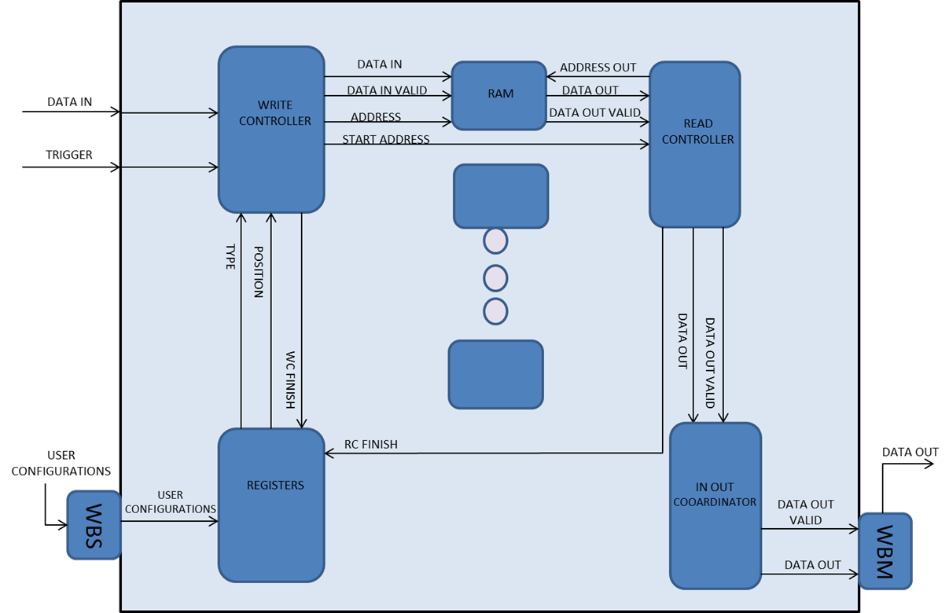

## 

1Figure 1 – top architecture

## **1.5 ENGINEERING TOOLS**

The tools which were used in this project are:

1. Altera DE2 Development and Education board with Altera Cyclone II 2C35 FPGA
2. Modelsim10.1d
3. Quartus II 12.1 for Place and Route.
4. Notepad ++
5. SVN

# 2 GENERAL DESCRIPTION

Our project is reusing blocks from other projects, such as: Rx Path, Tx Path,Wishbone Intercon, basic RAM.

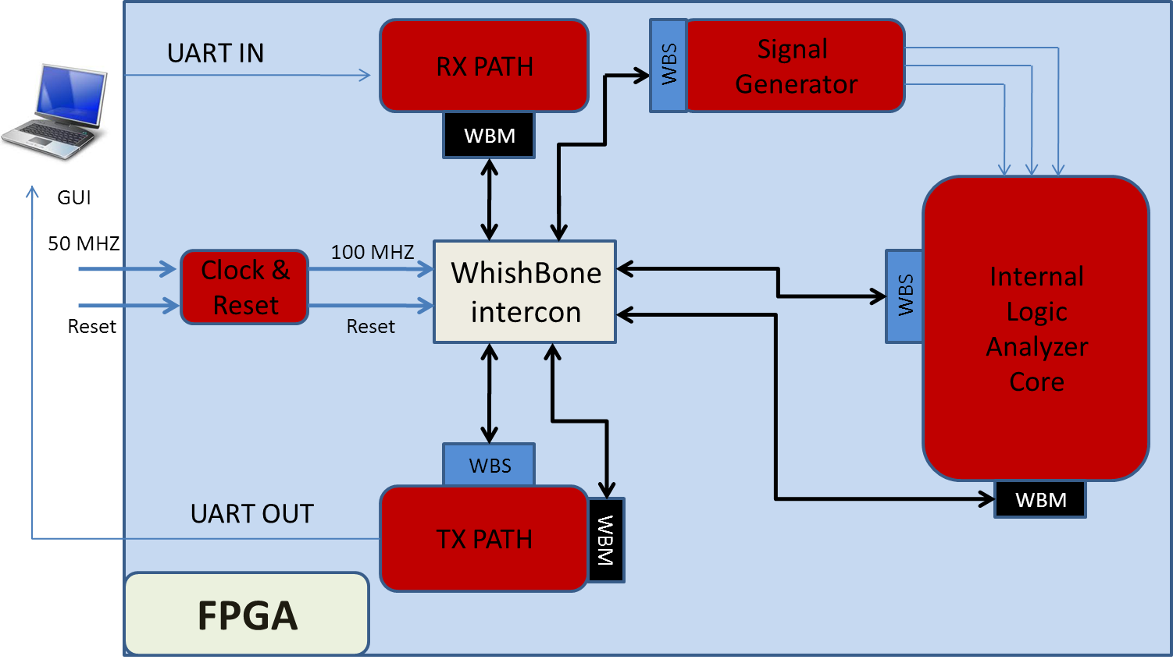

2Figure 2- the final system

## 2.1 DATA FLOW

Initial state: User chooses the desired configurations(trigger type, trigger position and enable) using the GUI. Host transmits the information through Uart to the RX path.Then through the wishbone intercon to the WS of the core.

The configurations are being saved the registers.(1)

Afterwards data and trigger from the signal generator are entering the WC.The WC uses the registers to determine the start address of the data and send it out to the RC. The WC also sends the data and validity signal to the RAM.(2)(3)

The RC uses this address to extract data from the RAM after the WC has finished.(4)

Then the In Out Coordinator will coordinate between the recorded data's width to the width of the bus in the Wishbone protocol.

The data will be sent back to host through WM.(5)

Flow diagram:

# 

3Figure 3 – flow diagram – (1)

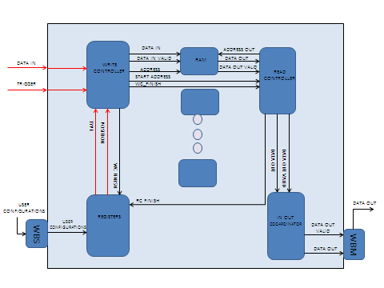

4Figure 4 – flow diagram – (2)

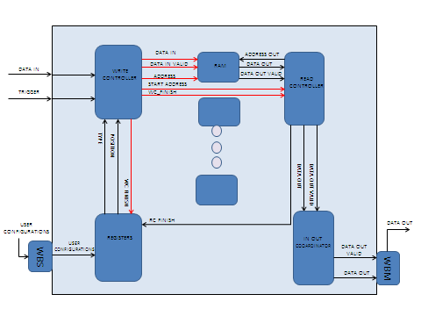

5Figure 5 – flow diagram – (3)

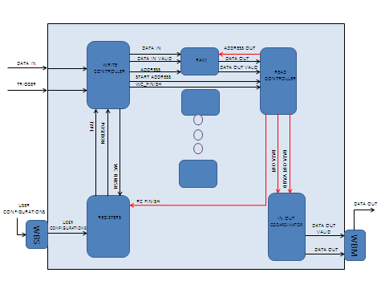

6Figure 6 – flow diagram – (4)

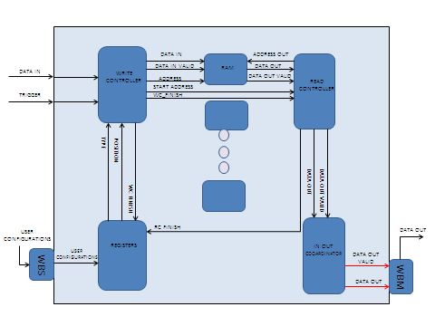

7Figure 7 – flow diagram – (5)

# **3 MICRO ARCHITECTURE**

## 3.1 REGISTERS UNIT

### 3.1.1 Description:

The Core Registers unit receives data from the wishbone slaves, samples it, and transmits it to the core blocks. When reset is activated no register should be enabled. The register's addresses are defined by generics.

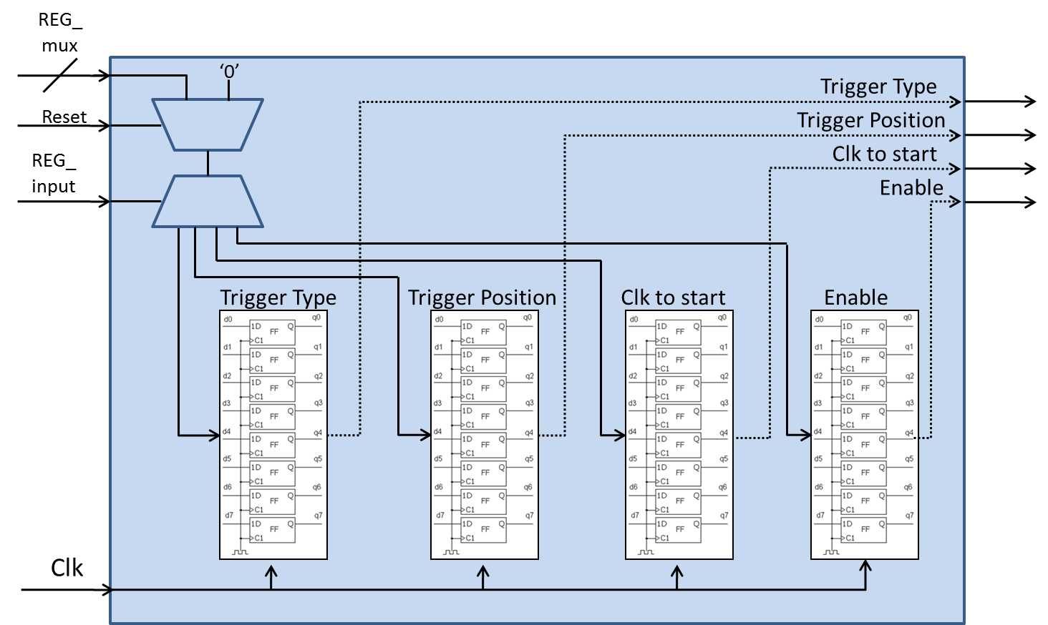

8Figure 8 – registers unit

The unit contains four registers which are configed as follow:

trigger_type_reg_1 = trigger_type

trigger_position_reg_2 = trigger_position

clk_to_start_reg_3 = clk_to_start

enable_reg_4 = enable

Generic table

|  |  |  |
| --- | --- | --- |
| Name | Width | Description |
| reset_polarity_g | 1 | '1' reset active high, '0' active low |
| enable_polarity_g | 1 | '1' the entity is active high, '0' entity isactive low |
| data_width_g | 8 | defines the width of the data lines of the system |
| Add_width_g | 8 | width of addr word in the RAM |
| en_reg_address_g | 1 | Enable the registers for reading |
| trigger_type_reg_1_address_g | 1 | Address of the type register |
| trigger_position_reg_2_address_g | 1 | Address of position register |
| clk_to_start_reg_3_address_g | 1 | Address of counter register |
| enable_reg_address_4_g | 1 | Address of enable register |

1Table 1- registers unit generics

Signals table

|  |  |  |  |
| --- | --- | --- | --- |
| Name | Direction | Width | Description |
| clk | In | 1 | System clock |
| Reset | In | 1 | System reset |
| address_in | In | Add_width_g | Address of the register that the data is writing to. (determine by the generics) |
| wr_en | In | 1 | write enable: '1' for write, '0' for read |
| data_in_reg | In | data_width_g | data sent from WS to store in the registers |
| valid_in | In | 1 | Data in valid |
| rc_finish | In | 1 | When signal rise we reset enable register |
| wc_finish | In | 1 | After write controller finish, we need to input a new configurations |
| en_out | Out | 1 | Enable reading from registers |
| trigger_type_out_1 | Out | 7 | Trigger type |
| trigger_positionout_2 | Out | 7 | Trigger position |
| clk_to_start_out_3 | Out | 7 | Trigger counter |
| enable_out_4 | Out | 1 | System enable |

2Table 2- registers unit signals

### 3.1.2 Simulation

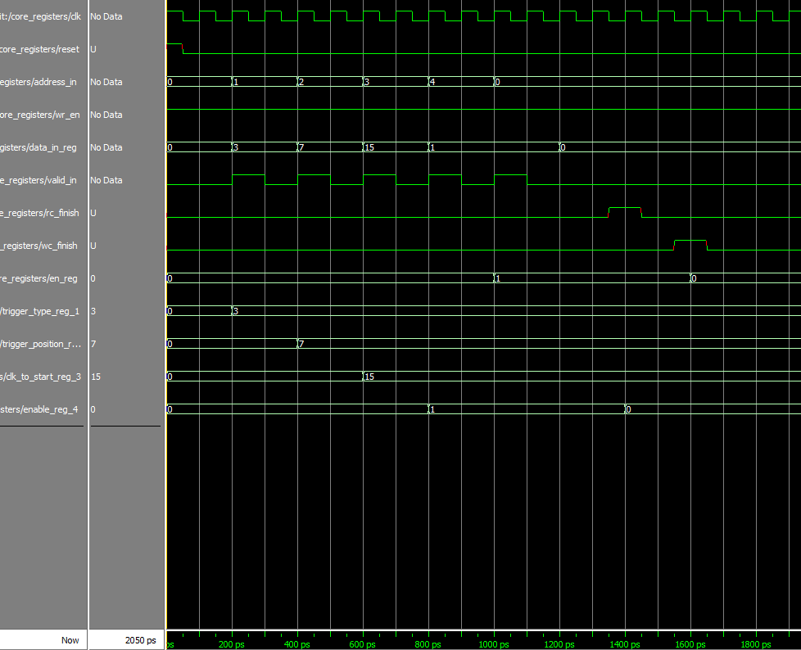

9Figure 9-registers unit simulation

We can see a data that is written to each one of the registers. In addition we can see that after wc_finish signal rise, the registers are not enabled- register number 0 is resetting into 0 (the configuration need to be enabled again), and when rc_finish signal rise (system output all the data back to the user), the enable register is resetting back into 0, (register number 4).

## 3.2 WRITE CONTROLLER

### 3.2.1 Description:

1. The entity gets the incoming data and trigger signals from the signal generator, calculating the address in the RAM that the data will be saved in, and sending the data and address to the RAM.
2. According the configurations that are saved in the core registers, detecting trigger rise and calculating the start address of the outputting data, and send it to the read controller.

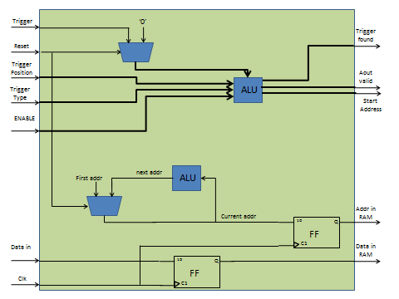

10Figure 10-write controller

Generic table

|  |  |  |
| --- | --- | --- |
| Name | Width | Description |
| reset_polarity_g | 1 | '1' reset active high, '0' active low |
| enable_polarity_g | 1 | '1' the entity is active high, '0' entity isactive low |
| signal_ram_depth_g | 3 | depth of single RAM is 2^signal_ram_depth_g |
| signal_ram_width_g | 8 | width of single RAM |
| record_depth_g | 4 | number of bits that are recorded from each signal is 2^record_depth_g |
| data_width_g | 8 | defines the width of the data lines of the system |
| Add_width_g | 8 | width of addr word in the RAM |
| num_of_signals_g | 8 | number of signals that will be recorded simultaneously |

3Table 3- write controller generics

Signals table

|  |  |  |  |
| --- | --- | --- | --- |
| Name | Direction | Width | Description |
| clk | In | 1 | System clock |
| Reset | In | 1 | System reset |
| Enable | In | 1 | Enabling the entity. if (enable = enable_polarity_g) -> start working, else-> do nothing |
| trigger_position_in | In | 7 | The percentage of the data that is recorded before trigger rise |
| trigger_type_in | In | 7 | Type of trigger |
| config_are_set | In | 1 | '1'-> configurations from registers are ready to be read (trigger position + type). '0'->config are not ready |
| data_in | In | num_of_signals_g | Data in from signal generator |
| Trigger | In | 1 | Trigger signal from signal generator |
| data_out_of_wc | Out | num_of_signals_g | sending the data to be saved in the RAM |
| addr_out_to_RAM | Out | Add_width_g | the address in the RAM to save the data |
| write_controller_finish | Out | 1 | '1' ->WC has finish working and saving all the relevant data (RC will start work), '0' ->WC is still working |
| start_addr_out | Out | Add_width_g | The start address of the data that we need to send out to the user |
| din_valid | Out | 1 | Data to RAM valid |

4Table 4- write controller signals

Write controller FSM

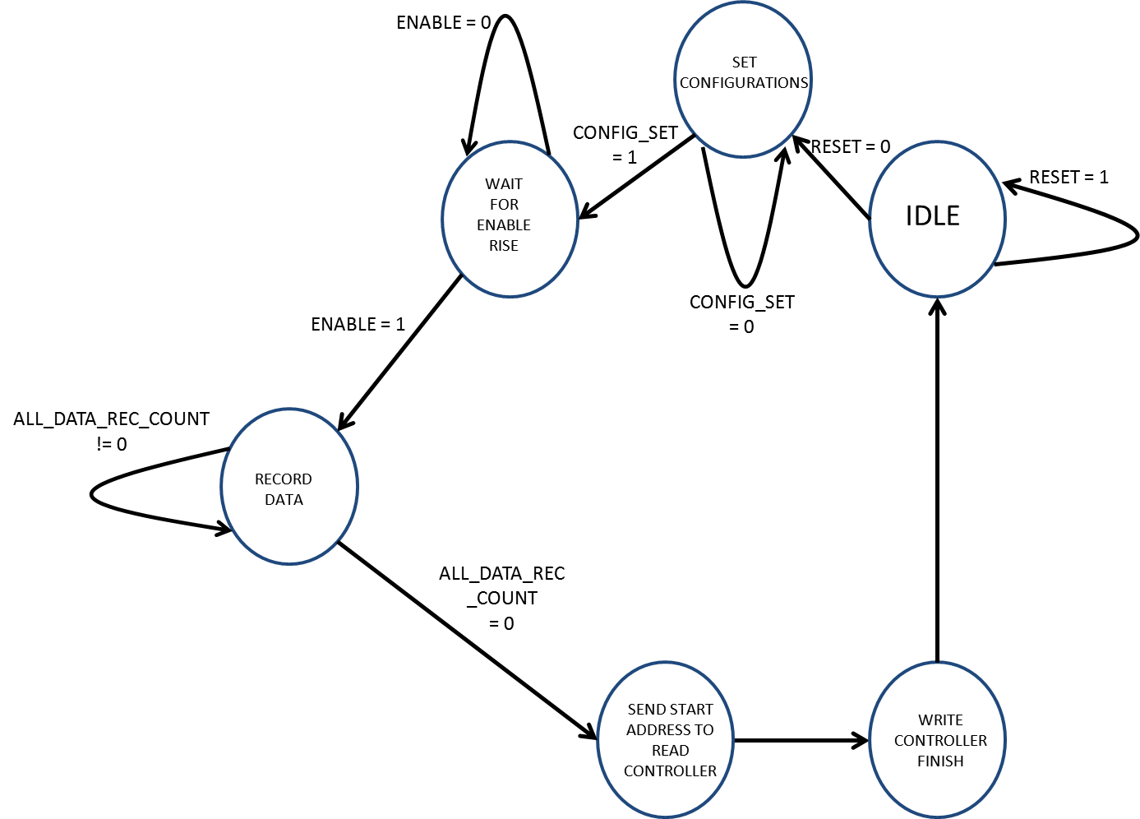

11Figure 11- write controller FSM

Output table

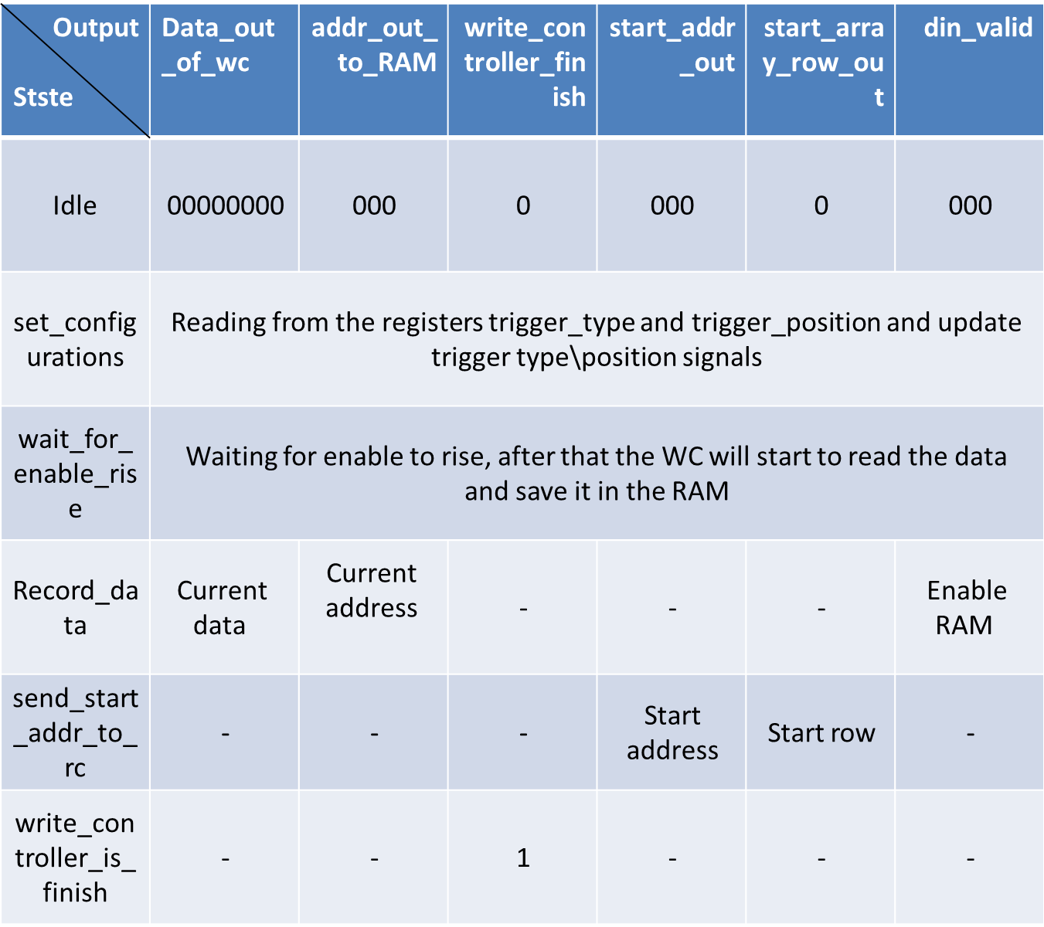

5Table 5- write controller output

### 3.2.2 SIMULATON

### 

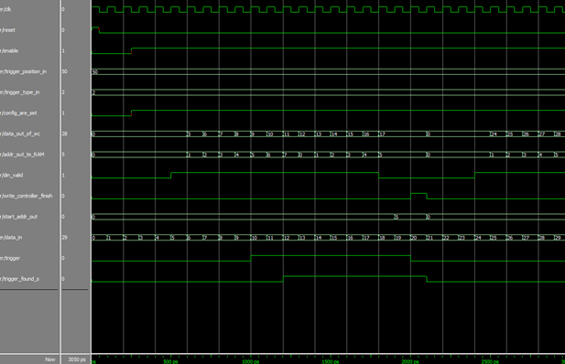

12Figure 12-write controller simulation

Trigger and data are entering each cycle. Data address and validity are being calculated and are being sent to the RAM. Trigger is compared to the configuration to identify trigger rise. If necessary start address is calculated according to the position and is being sent out

## 3.3 READ CONTROLLER

### 3.3.1 Description:

The read controller gets the start address of the valid data that was calculated in the write controllerand extract the correct data from the RAM and send it out.

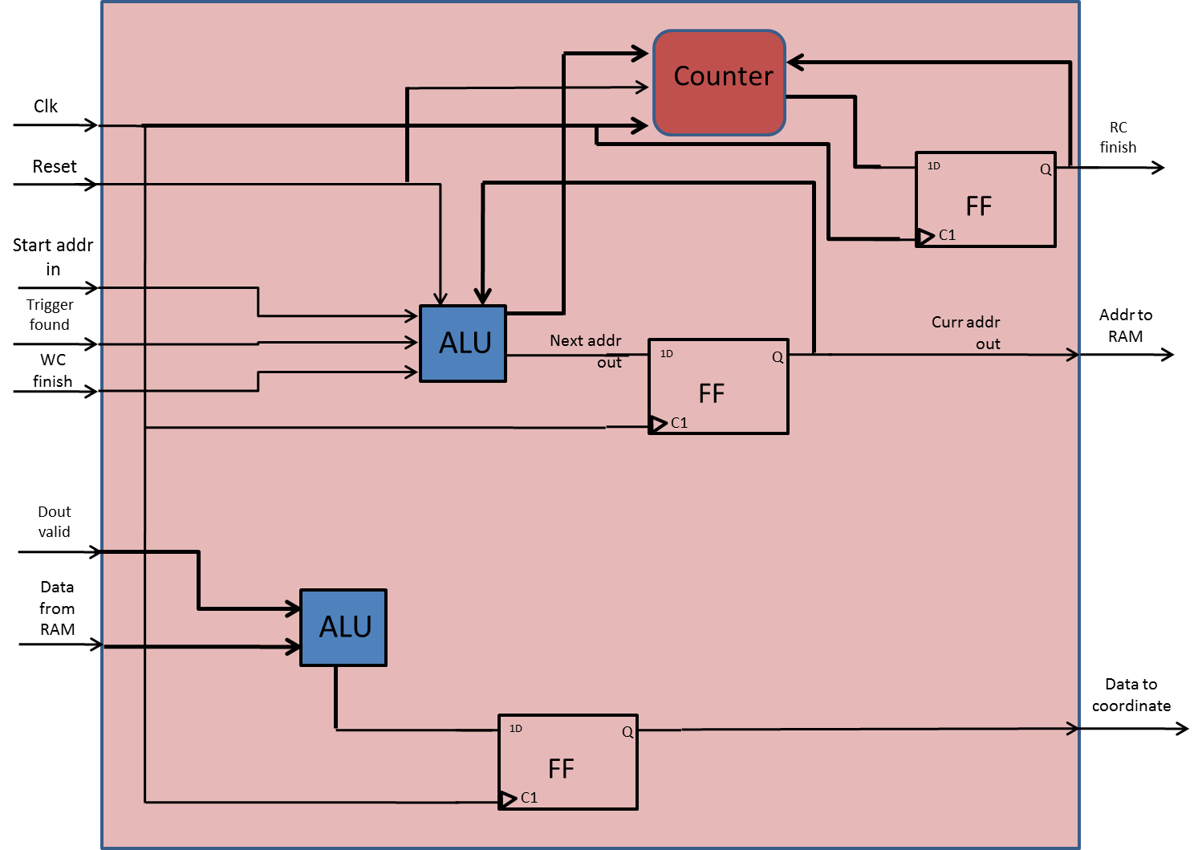

13Figure 13-read controller

Generic table

|  |  |  |
| --- | --- | --- |
| Name | Width | Description |
| reset_polarity_g | 1 | '1' reset active high, '0' active low |
| record_depth_g | 4 | number of bits that are recorded from each signal is 2^record_depth_g |
| data_width_g | 8 | defines the width of the data lines of the system |
| num_of_signals_g | 8 | number of signals that will be recorded simultaneously |

6Table 6- read controller generics

Signals table

|  |  |  |  |
| --- | --- | --- | --- |
| Name | Direction | Width | Description |
| clk | In | 1 | System clock |
| Reset | In | 1 | System reset |
| start_addr_in | In | record_depth_g | The start address of the data that we need to send out to the user |
| write_controller_finish | In | 1 | '1' ->WC has finish working and saving all the relevant data |
| dout_valid | In | 1 | Data coming from RAM validity |
| data_from_ram | In | num_of_signals_g | Data coming from RAM |
| data_in | In | num_of_signals_g | Data in from signal generator |
| read_controller_finish | Out | 1 | 1 -> RC finish sending all the data out. 0 -> other |
| addr_out | Out | record_depth_g | Address sent to the RAM in order to extract it out back to the user |
| aout_valid | Out | 1 | Validity of address that sent to the RAM |
| data_out_to_WBM | Out | num_of_signals_g | Data sent out back to the user |
| data_out_to_WBM_valid | Out | Add_width_g | Validity of the outputting data |

7Table 7- read controller signals

Read controller FSM

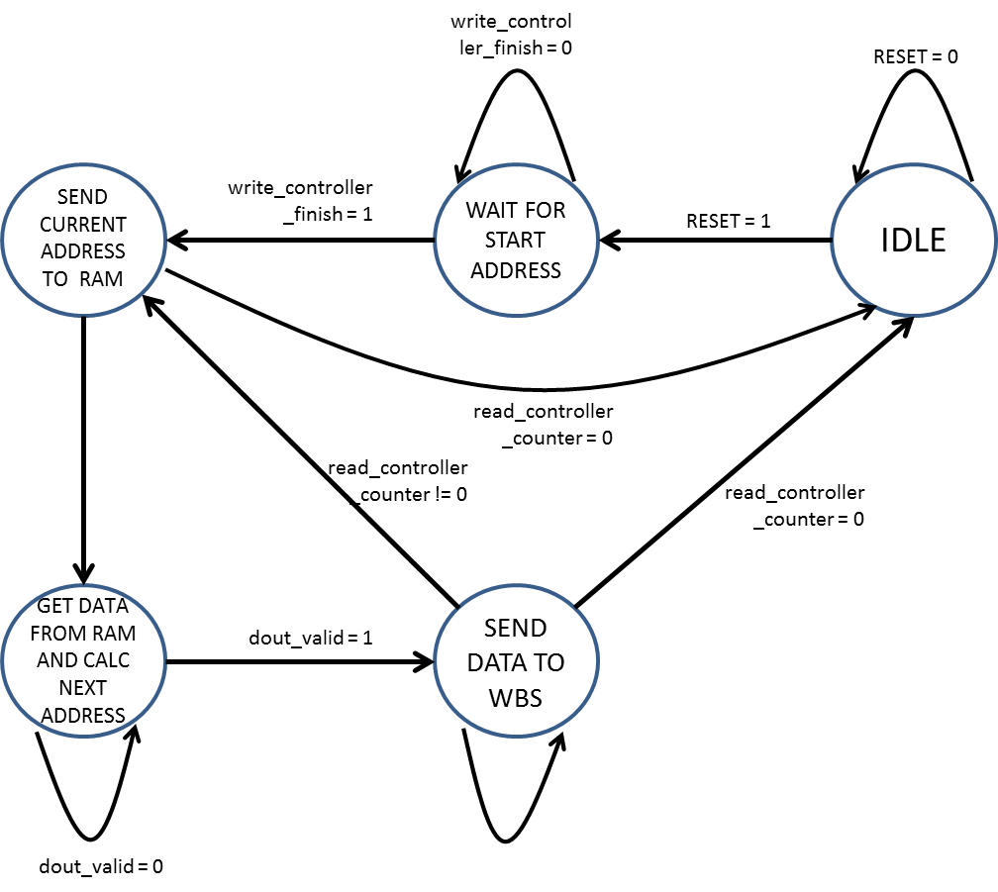

14Figure 14-read controller FSM

Output table

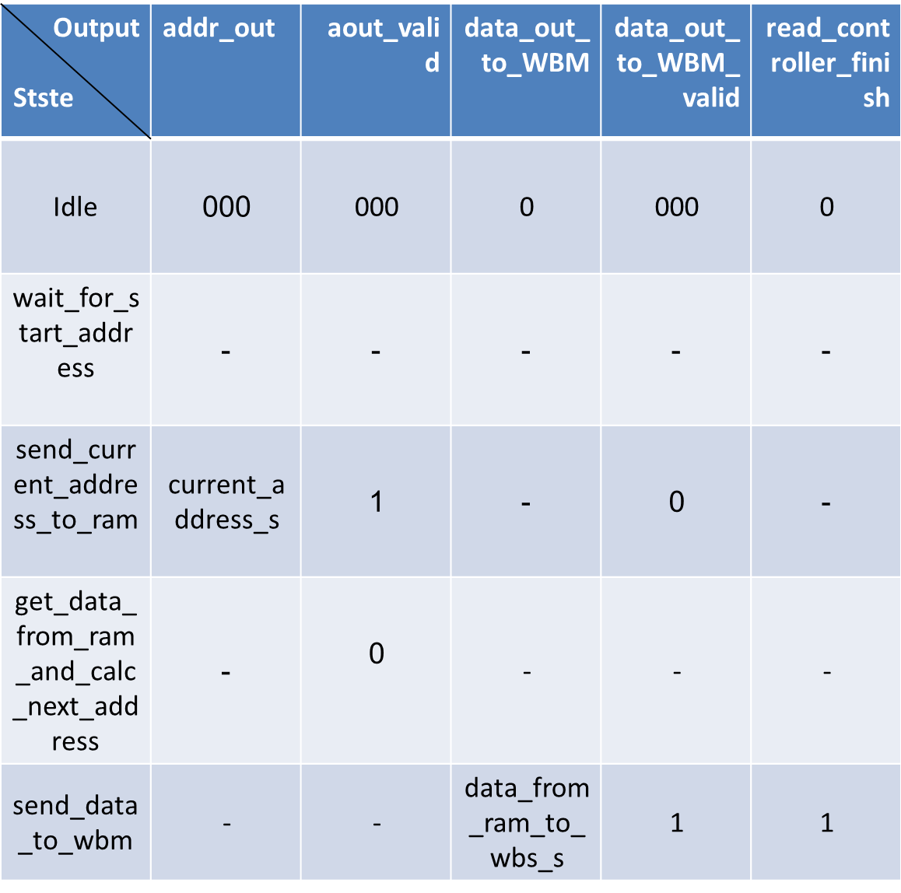

8Table 8- read controller output

### 3.3.2SIMULATION

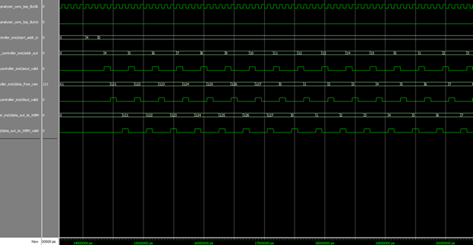

15Figure 15-read controller simulation

Start address is received. The next address is calculated and sent to the RAM. Data and validity is received from RAM. Output data is being sent to the coordinator.

## 3.4 IN OUT COORDINATOR:

### 3.4.1 Description:

Coordinate between input data (num_of_signals_g) to output data (data_width_g)

If input < output use in_small_out_cordinator,

if input = output use in_equal_out_cordinator,

else (input > output) use in_big_out_cordinator.

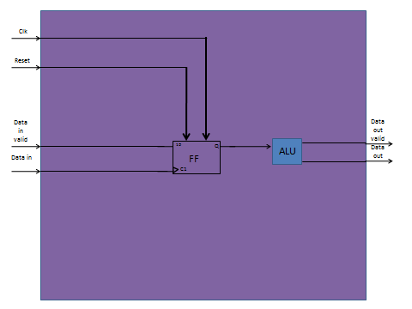

16Figure 16-in out coordinator

Generic table

|  |  |  |
| --- | --- | --- |
| Name | Width | Description |
| reset_polarity_g | 1 | '1' reset active high, '0' active low |
| out_width_g | 3 | Width of outputting data |
| in_width_g | 8 | Width of incoming data |

9Table 9- in out coordinator generics

Signals table

|  |  |  |  |
| --- | --- | --- | --- |
| Name | Direction | Width | Description |
| clk | In | 1 | System clock |
| Reset | In | 1 | System reset |
| data_in | In | in_width_g | Incoming data |
| data_in_valid | In | 1 | Incoming data valid |
| data_out | In | out_width_g | Outputting data |
| data_out_valid | In | 1 | Outputting data valid |

10Table 10- in out coordinator signals

### 

### 

### 3.4.2 Simulation

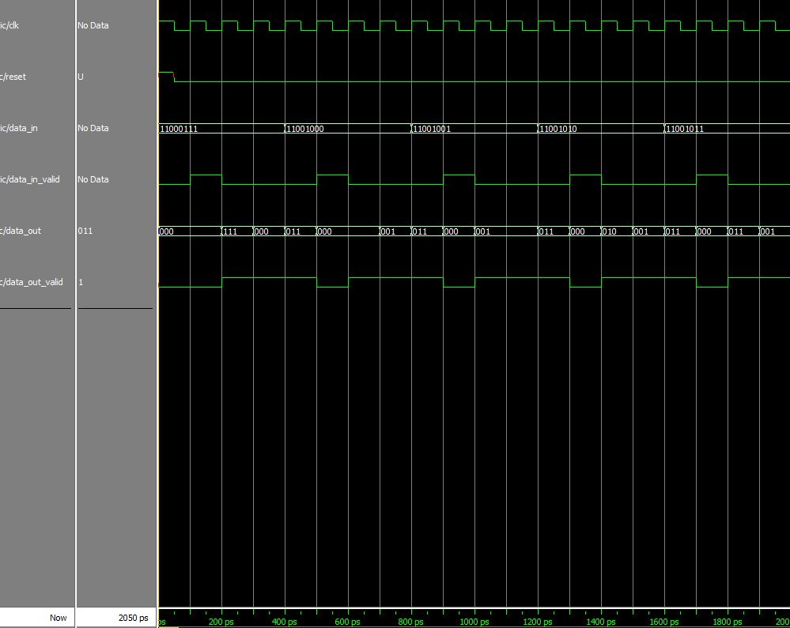

17Figure 17-in out coordinator simulation

In that example, the input width is 8 and the output width is 3.

Each time that data_in_valid signal rise, the entity sample the input and start to "break" it to output signals in the width of 3. Of course that one "output cycle" take us 3 clock cycle and for that reason we can see that data_out_valid signal is high 3 clock cycles each time. The sampled input data is divided in order to keep the value of the original input, meaning that we start outputting the number from the less significant bit (LSB) to the most significant bit (MSB), and if needed (like in that case) we add 0 to the MSB of the last output data.

In our example we divide the input 11000111 to the outputs of: first- 111, second- 000 third- 011. We can see that one 0 was added to the last output in order to fit him to the output width.

### 3.5 INPUT>OUTPUT COORDINATOR

### 3.5.1 Description:

Coordinate between input data (num_of_signals_g) to output data (data_width_g) when input > output.We save at first the incoming data (when it is valid) and start to output it in the width of out_width_g every clock cycle. In the case that the last output is smaller than that width, we add 0 to the MSB until it's fit, in order to not change the number value.

Generic table

|  |  |  |
| --- | --- | --- |
| Name | Width | Description |
| reset_polarity_g | 1 | '1' reset active high, '0' active low |
| out_width_g | 3 | Width of outputting data |
| in_width_g | 8 | Width of incoming data |

**11**Table 11- in> out coordinator generics

Signals table

|  |  |  |  |
| --- | --- | --- | --- |
| Name | Direction | Width | Description |
| clk | In | 1 | System clock |
| Reset | In | 1 | System reset |
| data_in | In | in_width_g | Incoming data |
| data_in_valid | In | 1 | Incoming data valid |
| data_out | In | out_width_g | Outputting data |
| data_out_valid | In | 1 | Outputting data valid |

12Table 12- in> out coordinator signals

## INPUT> OUTPUT CORDINATOR FSM

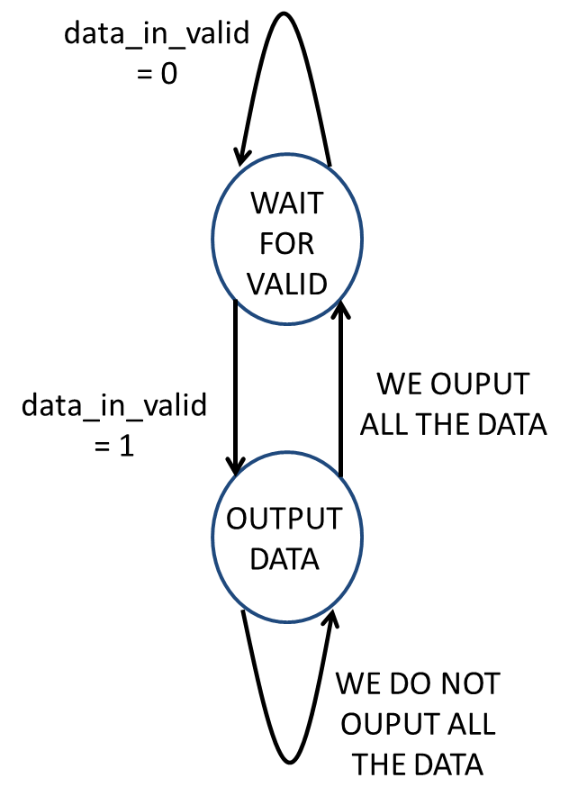

18Figure 18-in >out coordinator FSM

Output table

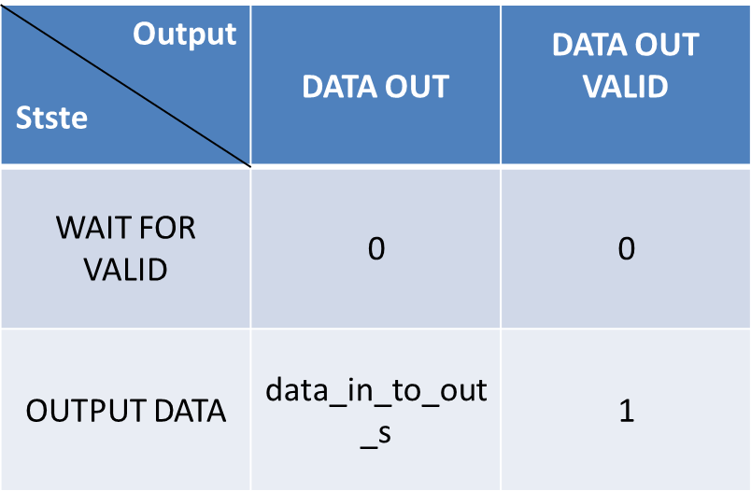

13Table 13- in> out coordinator output

### 3.6 INPUT<OUTPUT COORDINATOR

### 3.6.1 Description:

Coordinate between input data (num_of_signals_g) to output data (data_width_g) when input < output.We save at first the incoming data (when it is valid) and in the next clock cycle we output it. We add 0 to the MSB until it's fit to out_width_g , in order to not change the number's value.

Generic table

|  |  |  |
| --- | --- | --- |
| Name | Width | Description |
| reset_polarity_g | 1 | '1' reset active high, '0' active low |
| out_width_g | 3 | Width of outputting data |
| in_width_g | 8 | Width of incoming data |

14Table 14- in< out coordinator generics

Signals table

|  |  |  |  |
| --- | --- | --- | --- |
| Name | Direction | Width | Description |
| clk | In | 1 | System clock |
| Reset | In | 1 | System reset |
| data_in | In | in_width_g | Incoming data |
| data_in_valid | In | 1 | Incoming data valid |
| data_out | In | out_width_g | Outputting data |
| data_out_valid | In | 1 | Outputting data valid |

15Table 15- in< out coordinator signals

INPUT< OUTPUT CORDINATOR FSM

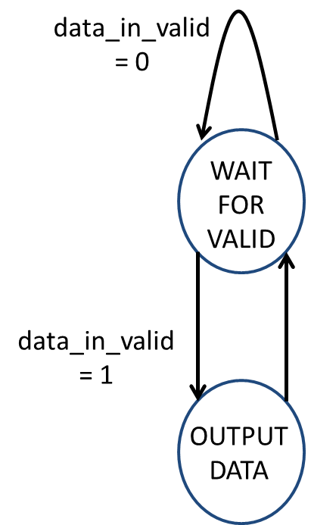

19Figure 19-in <out coordinator FSM

Output table



16Table 16- in< out coordinator output

### 3.7 INPUT=OUTPUT

### 3.7.1 Description:

Coordinate between input data (num_of_signals_g) to output data (data_width_g) when input > output.We save at first the incoming data (when it is valid) and start to output it in the width of out_width_g every clock cycle. In the case that the last output is smaller than that width, we add 0 to the MSB until it's fit, in order to not change the number value.

Generic table

|  |  |  |
| --- | --- | --- |
| Name | Width | Description |
| reset_polarity_g | 1 | '1' reset active high, '0' active low |
| out_width_g | 3 | Width of outputting data |
| in_width_g | 8 | Width of incoming data |

17Table 17- in= out coordinator generics

Signals table

|  |  |  |  |
| --- | --- | --- | --- |
| Name | Direction | Width | Description |
| clk | In | 1 | System clock |
| Reset | In | 1 | System reset |
| data_in | In | in_width_g | Incoming data |
| data_in_valid | In | 1 | Incoming data valid |
| data_out | In | out_width_g | Outputting data |
| data_out_valid | In | 1 | Outputting data valid |

18Table 18- in= out coordinator signals

INPUT=OUTPUT CORDINATOR FSM



Figure 20-in =out coordinator FSM

Output table



19Table 19- in= out coordinator output

## 3.8 ENABLE FSM

### 3.8.1 Description:

State Machine for enabling write controller, determine when to enable the WC.

RC enable is through WC_finish signal

Generic table

|  |  |  |
| --- | --- | --- |
| Name | Width | Description |
| reset_polarity_g | 1 | '1' reset active high, '0' active low |
| enable_polarity_g | 1 | '1' the entity is active high, '0' entity isactive low |

20Table 20 – enable generics

Signals table

|  |  |  |  |
| --- | --- | --- | --- |
| Name | Direction | Width | Description |
| clk | In | 1 | System clock |
| Reset | In | 1 | System reset |
| Enable | In | 1 | Enabling the entity. if (enable = enable_polarity_g) -> start working, else-> do nothing. Come from registers |
| wc_finish | in | 1 | '1' ->WC has finish working and saving all the relevant data (RC will start work), '0' ->WC is still working |
| rc_finish | in | 1 | '1' -> read controller finish working, '0' -> system still working |
| enable_out | Out | 1 | Enable send to the write controller to start saving the data and searching trigger rise |

21Table 21 – enable signals

Enable FSM

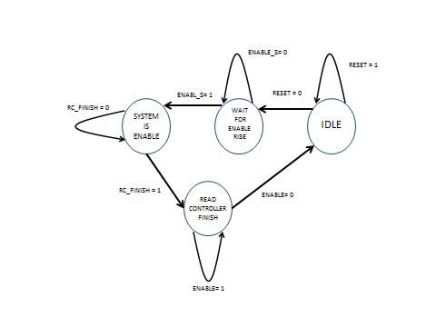

21Figure 21-enable FSM

Output table

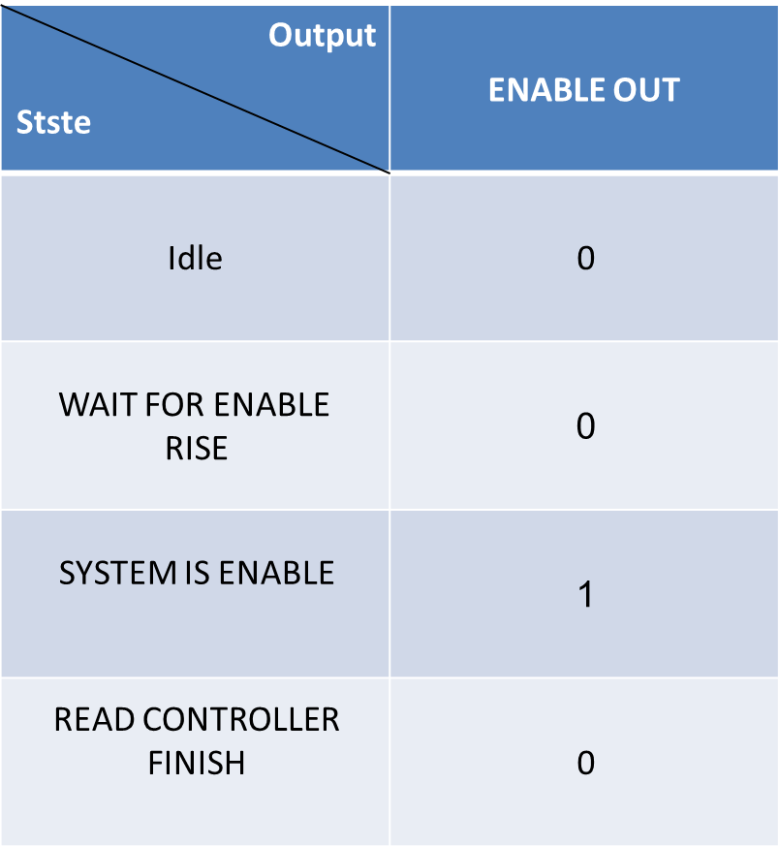

22Table 22– enable output

## 3.9 MEMORY UNIT

### 3.9.1 Description:

The memory unit is implemented as an array of RAMs, when the depth and width of each one of them is known. We used them to implement the memory unit by the width and depth we need.

clk

Reset

addr_in data_out

RAM

RAM

addr_out

aout_valid

data_in

din_valid

RAM

dout_valid

22figure 22-memory unit

Generic table

|  |  |  |
| --- | --- | --- |
| Name | Width | Description |
| reset_polarity_g | 1 | '1' reset active high, '0' active low |
| width_in_g | 8 | Width of data |
| addr_bits_g | 4 | Depth of data (2^4 = 16 addresses) |
| power2_out_g | 0 | Output width is multiplied by this power factor (2^1). In case of 2: output will be (2^2*8=) 32 bits wide |
| power_sign_g | 1 | '-1' => output width > input width ; '1' => input width > output width |

23Table 23 – memory unit generics

Signals table

|  |  |  |  |
| --- | --- | --- | --- |
| Name | Direction | Width | Description |
| clk | In | 1 | System clock |
| Reset | In | 1 | System reset |
| addr_in | In | addr_bits_g | Input address |
| addr_out | In | addr_bits_g | Output address |
| aout_valid | In | 1 | Output address is valid |
| data_in | In | width_in_g | Input data |
| din_valid | In | 1 | Input data valid |
| data_out | Out | width_in_g | Output data |
| dout_valid | Out | 1 | Output data valid |

24Table 23 – memory unit signals

Number of RAM's determine be the formula:



# 4 SIMULATIONS

At first we made a manual simulation to each entity to check the functionality, afterwards, we built a core test bunch in order to check the entire core. Each diagram was checked and confirmed for the correct result and if necessary, code changes were made and the simulation were made again.

Simulation table:

We conducted about 17 simulations:

-

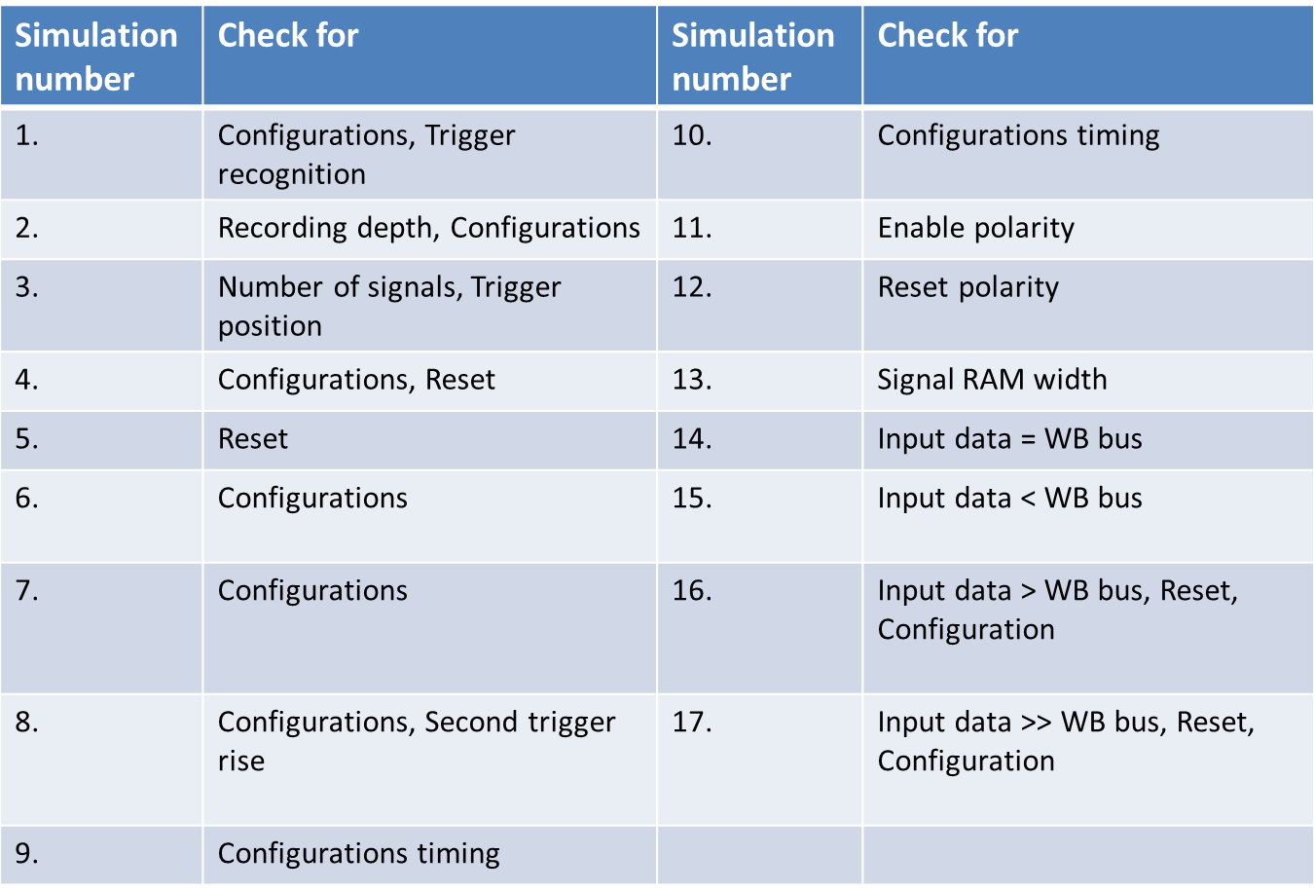

25Table 25- simulations

## 4.1 Description:

1. We enter the user's configurations through the WBS and save it in the registers, after that we wait for enable rise and the system start to save the data since that. When we detect trigger rise we continue to save the relevant data and after that send it out through the WBM.
2. We change the recording depth to 4 (2^4 = 16), position to 75% (meaning that 75% -> 12 bits, will recorded before the trigger and the other after that, we also change the trigger type to zeroes (number 3 ) so trigger will rise after three low sampling.
3. Number of signals is changed to 5, meaning our input data is between 0-32 in decimal (2^5), at first the trigger position is 100 and all the data is recorded before the trigger, and second time the position is 0 and all the data is recorded after the trigger.
4. In this simulation we check two trigger positions that are not complete, 15% and 85%.

We also change the trigger type, from 'zeroes' (3 low in a row) in the first one to rise in the second.

In the end we rise the RESET signal to show that the system responds to that signal.

1. We checked the RESET signal. At first trigger position is 15%, trigger type is low. While data is exiting we rise RESET signal and change trigger position to 85% and trigger type to rise. We now make sure that the system recognize trigger rise again.
2. This simulation checks for different types of trigger type and position. First check: type is rise, position is 0. Second check: type is fall, position is 10%. Third check: type is high, position is 30%.
3. Continue checking different types of trigger type and position. First check: type is low, position is 50%. Second check: type is rise, position is 70%. Third check: type is fall, position is 90%.
4. In this simulation we focus on changing configuration after trigger rise. We also check that trigger rise after we have already found trigger rise or after the data has already been extracted but there wasn’t another configure, will not affect the system.

At first we commit certain configuration, and after trigger rise and extracting the data, we can see that a second trigger rise doesn't cause data extraction until new configure is being committed.

In advance, we record 32 samples and make sure that the system react well to this value( record_depth_g=5).

1. Check of configuration position. In this simulation we can see that system configuration can occur even before the data was entirely extracted back to the user. But the second stream and trigger identification can only happen after the first stream has end( after READ CONTROLLER FINISH signal rise).

In this simulation we configure the system to first state and while the data is still extracting we configure to a different state. After all the data was extracted we only need to enable the register ENABLE and the system starts to work with the second configuration.

1. Another check of configuration's position. We change trigger type to all possible types, but configure the system only afterwards and check whether trigger rises when the system wasn’t configure.
2. We check the change in ENABLE signal that is now active low. At first we change the trigger signal to see that it doesn't rise before the system is configured. After enabling the system( ENABLE register is low) the system starts to save the data and look for trigger rise.
3. We check the change in RESET signal that is now active low. At first we configure the system, rise trigger and after few samples we enable RESET signal and configure the system to different values. We check the system reaction to RESET signal changes(active low instead of high), and how the system recovers after lowering RESET signal.
4. From this simulation on we replace the generic of address width Add_width_g by the generic record_depth_g.

We check the situation when single RAM width is wider than the width of the saved signals, i.e. signal_ram_width_g> num_of_signals_g.

1. In this simulation we compare the number of signals entering the BUS width' i.e.

num_of_signals_g = data_width_g.

1. In this simulation the BUS width is larger than the number of sampled signals, i.e num_of_signals_g > data_width_g.
2. In this simulation BUS width is smaller than the number of sampled signals, i.e. num_of_signals_g < data_width_g. As a result we can't extract the data in a single clock cycle (data width is 8), therefor we need two clock cycles.
3. In this simulation BUS width is still smaller than the number of sampled signals, but now we have enlarged the saved data width.

* For more information: <http://moran-zvika-project.googlecode.com/svn/trunk/Documentation/> [סימולציות internal_logic_ananlyzer_core_top.docx](http://moran-zvika-project.googlecode.com/svn/trunk/Documentation/core/%d7%a1%d7%99%d7%9e%d7%95%d7%9c%d7%a6%d7%99%d7%95%d7%aa%20internal_logic_ananlyzer_core_top.docx)

## 4.2 EXAMPLE:

Data is insert to the registers, in order to configure the user trigger position and type, enable signal is written to the register to enable the system.

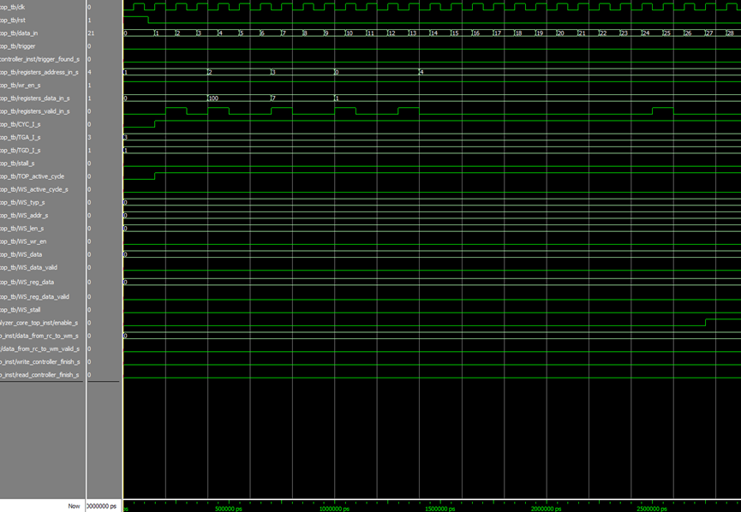

23Figure 23-simulation(1)

Data is being saved in the RAM until trigger rise, since position is 100, we do not save data after trigger rise.

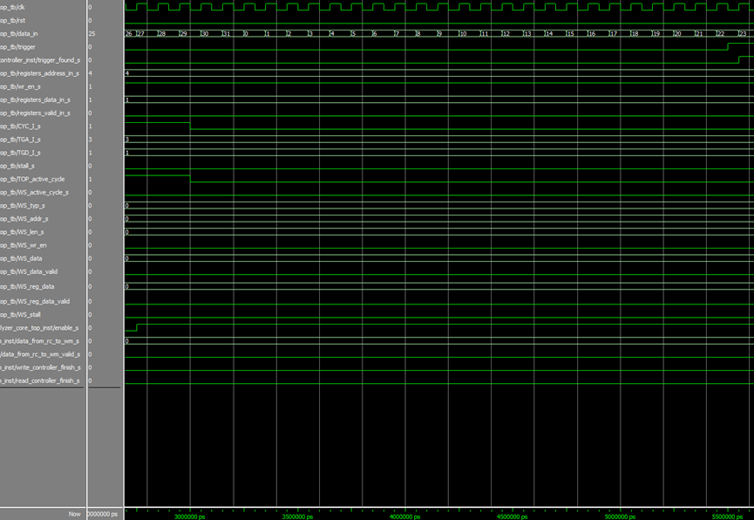

24Figure 24-simulation (2)

Write controller is finish, Read controller starting to send the relevant data out.

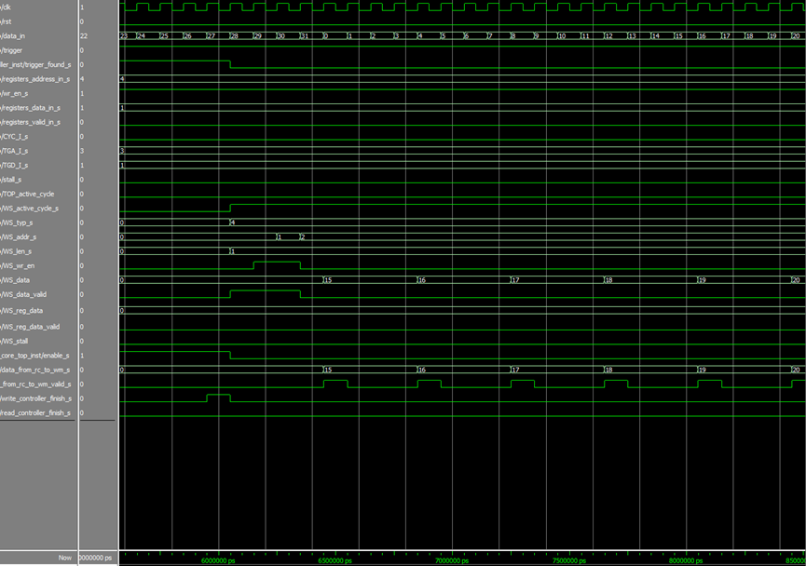

25Figure 25-simulation (3)

After that all the relevant data has being sent out, read controller finish working. We can now configure a new and different simulation

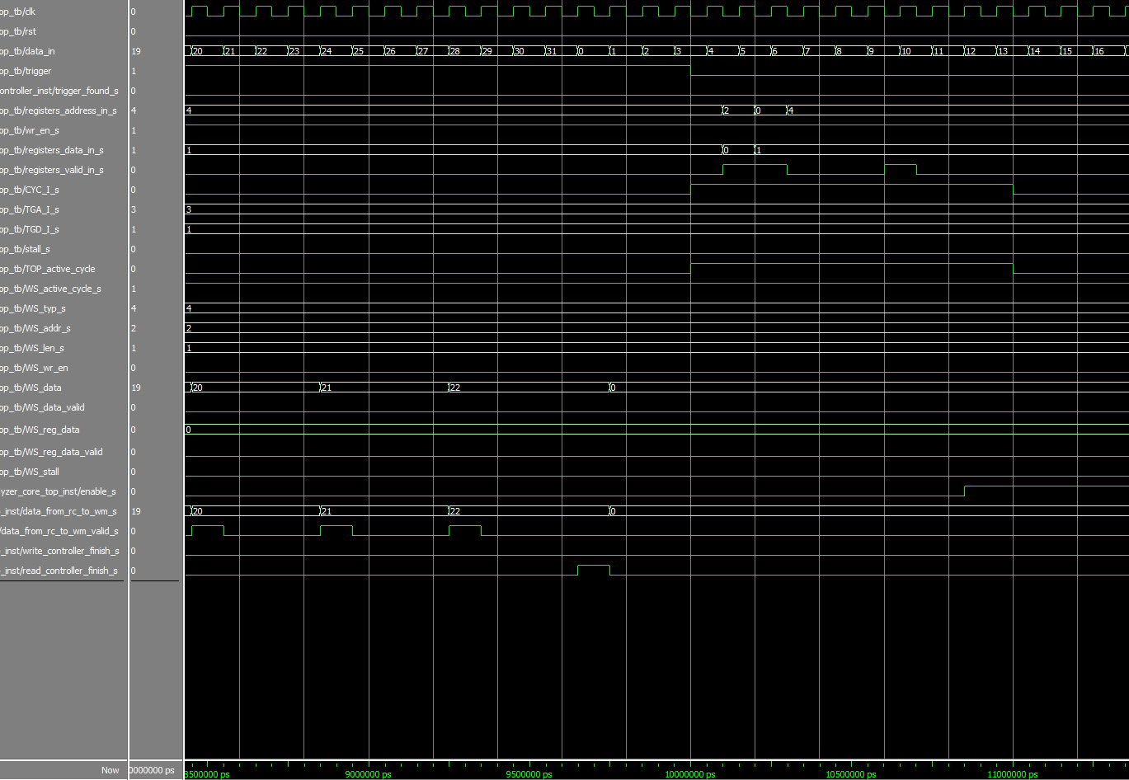

26Figure 26-simulation (4)

# 5 PROBLEMS AND SOLUTIONS

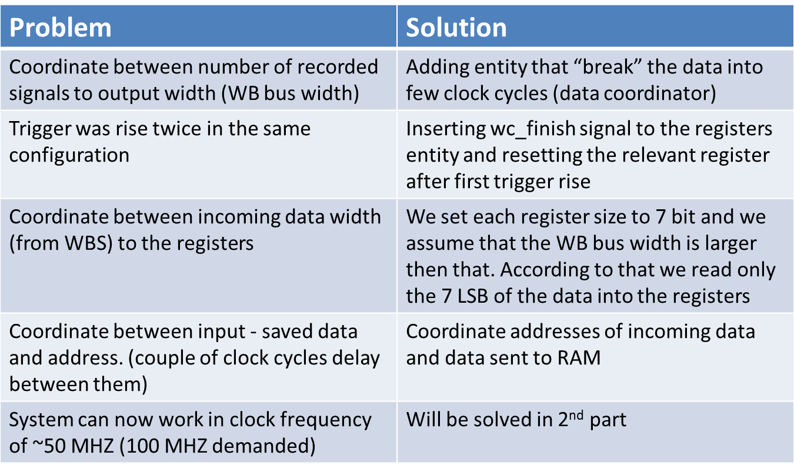

## EXMPLES

# First example: After first trigger rise, the system identify another trigger rise although the data was still recorded

# 

27Figure 27-first problem simulation

Problem- there was no dependency between two trigger rises

Our solution- adding wc_finish signal to the registers and resetting the enable register

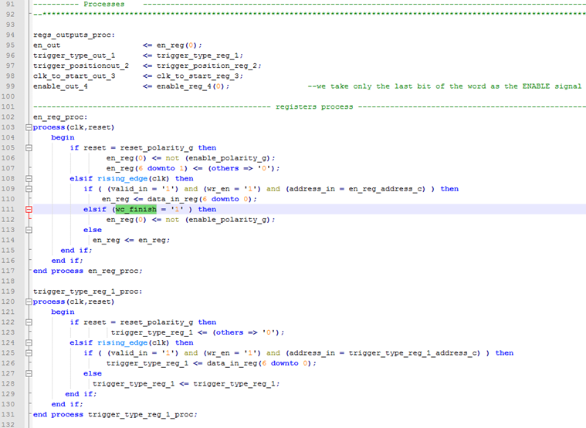

28Figure 28-code solution

Second example: Input width is num_of_signals_g, output width is data_width_g.

Problem- the two widths don’t match.



29Figure 29-second problem

Our solution- adding an entity that coordinates between them.

# 

30Figure 30-second solution

# 6 WORKING SYSTEMS

## 

## 

31Figure 31-SVN

## 6.1 SVN

The SVN proved to be a useful tool in the documentation process. The tool helps synchronizing the project designers and supervisor, document the changes with the project progress and backup each version. An SVN snapshot example can be shown below:

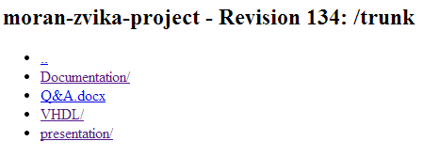

## 

32Figure 32-SVN snapshot

## 6.2 CODING GUIDELINES

The project was written according to strict coding guidelines which include code design according known conventions, usage of entity template.

For more information: <http://moran-zvika-project.googlecode.com/svn/trunk/Documentation/vhdl&modelsim%20guid/>

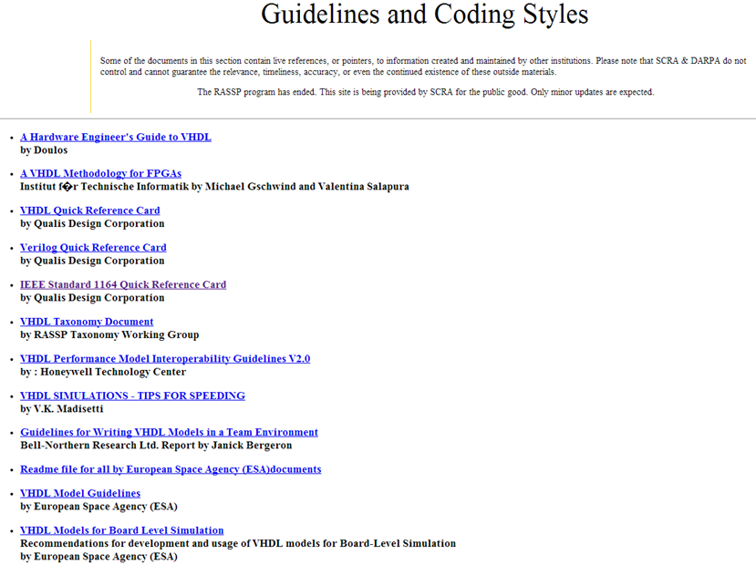

33Figure 33-coding guidelines

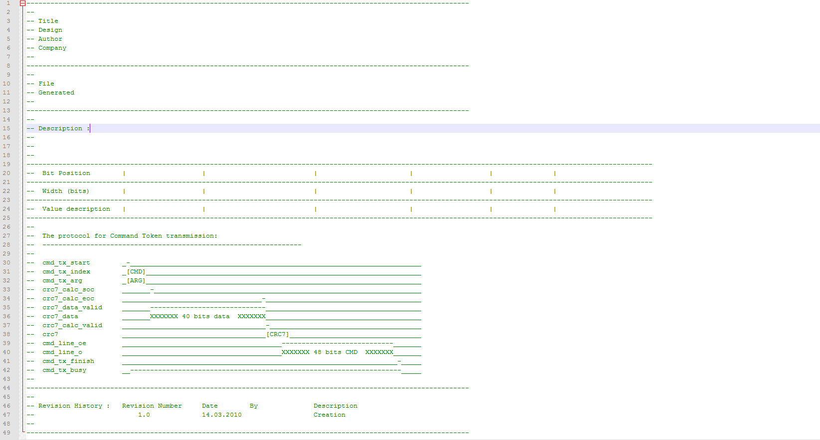

34Figure 34-entity template

## 6.3 CODE REVIEW

1. Visual/ Compiler

2.Local simulation to the entity- each block was tested separately, manually first then using test bunch.

3. Top simulation- after all blocks were combined, many simulations were made to check each situation.

## 6.4 DOCUMENTATION

Detailed documents of each block, and of the entire core, including simulations can be found in the link: <http://moran-zvika-project.googlecode.com/svn/trunk/Documentation/core/>

# 7 ABBREVIATIONS

WC – Write Controller

RC – Read Controller

CLK – Clock

RST – Reset

WM – Wishbone Master

WS – Wishbone Slave

UART – Universal Asynchronous Receiver Transmitter

RAM – Random Access Memory

FSM - final state machine